The Mississippi State Speech & Debate Council
presents
The Seventh Annual
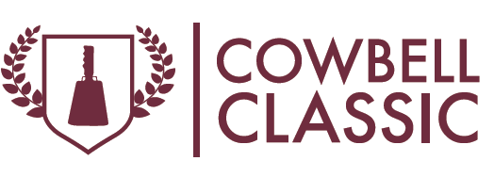
Dear Friends:
Greetings from the MSU Speech & Debate Council. It is our great pleasure to announce that the Seventh Annual Cowbell Classic will be held on January 20-21, 2023 on the campus of Mississippi State University.
We are once again proud to offer our usual slate of great awards, great food, and bids to the National Individual Events Tournament of Champions (NIETOC). For those of you seeking qualifying legs, come on down (or up) and enjoy our hospitality.
The Events
We will follow the standard MHSAA tournament format. Debate preliminary rounds will be held on Friday afternoon and evening, with elimination rounds on Saturday. All individual event rounds will be held on Saturday.
Competitors may enter up to four total events. Either (1) Up to two IE’s in each flight; or (2) One debate event, and up to one IE in Flight A and two in Flight B. This allows us to schedule debate elimination rounds parallel to Flight A.
Debate Events: Congressional Debate, Lincoln-Douglas, Public Forum, Policy Debate
Flight A Individual Events: Prose Interpretation, Dramatic Interpretation, Duet Acting, Original Oratory, Program Oral Interpretation, Impromptu Speaking
Flight B Individual Events: Extemporaneous Speaking, Humorous Interpretation, Duo Interpretation, Poetry Interpretation, Declamation, Informative Speaking
Awards
We offer our usual suite of top-notch individual awards, including trophies, plaques, and medals in all events. Sweepstakes will include (1) top three overall team sweeps; (2) top three debate sweeps; and (3) the highly-coveted cowbells for the top three individual performers.

Registration, Judges, and Entry Fees
Registration will close on Monday, January 16th at 7 p.m. Entry fees will be our standard $10 per entry, regardless of event. Drops or adds by registered schools are permitted without penalty until 7 p.m. on Tuesday, January 17th. Drop fees will apply after this point.
As usual, we will attempt to recruit a strong pool of judges from the MSU community, but it’s impossible to predict availability, so we strongly prefer that schools provide actual judges rather than pay judge fees, if at all possible.
And as always, we are happy to waive entry fees for schools that are in their first or second year of competition, or their first or second year back after an absence of at least five years.
Legislation
Unlike previous years, the Cowbell Classic will now feature bills and resolutions assigned from the MHSAA legislation packet.
Questions
Please feel free to contact Brett Harvey at brett.harvey@msstate.edu or 662-325-8124 with any questions. We’re looking forward to seeing everyone on January 20-21, 2023 for a weekend of fun and great competition. Hail State!
Best regards,

The MSU Speech & Debate Council

