Design a Speech and Debate T-Shirt

Clock Partners

Directions: Find a different partner for the times 2, 4, 6, 8, 10, 12. You cannot pick someone you are already friends with. Try to partner with teammates you do not know well.
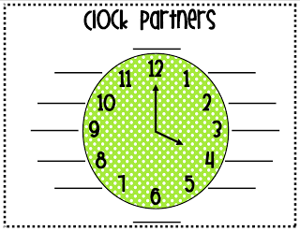

With your 12 o’clock partner:
- Play “Two truths and a lie”
With your 10 o’clock partner:
- Using the back of the sheet, design a Speech and Debate T-shirt.
With your 8 o’clock partner:
- Answer the silly questions on the attached sheet of paper. Be prepared to share!
With your 6 o’clock partner:
- Look up and write down a fun tongue twister. Practice so you can teach the group later.
With your 4 o’clock partner:
- Answer the silly questions on the next page and prepare to share the best answers!
With your 2 o’clock partner:
- Discuss goals for Speech and Debate this year. Write them below.

Team Goal: Individual Goal:

Silly Questions
- If you woke up tomorrow as an animal, what animal would you choose to be and why?

- If you could live anywhere on this planet and take everything that you love with you, where would you choose to live? Why?

- If you could choose an imaginary friend, who would you choose and why?

- If you could choose your age forever, what age would you choose and why?

- If you could be in the movie of your choice, what movie would you choose and what character would you play?

- If you could meet any historical figure, who would you choose and why?

- What are your ten favorite foods?

- If you were to change your name, what name would you adopt going forward? Why?

- If you were stranded on a desert island, what three items would you want to have with you?

- Share a description of your favorite material object that you already own?

- If you were to create a slogan for your life, what would it be? (Example: Eat, drink, and be merry, for tomorrow, we all die.)

